**DIGITAL MARKETING**

**ASSIGNMENT-1**

|  |  |
| --- | --- |
| Name | GOPIKA V.S |
| Reg No | 960220106051 |
| NM ID | 3F81B5FB0871DB4A50C42A1FB3C672C6 |
| TeamID | NM2023TMID10148 |

Create a blog or website using Blogspot and WordPress.  
Customize the theme design and post new article with 500  
words.

**Blogspot:**

[**https://sparkaccessories.blogspot.com/2023/08/spark-accessories.html**](https://sparkaccessories.blogspot.com/2023/08/spark-accessories.html)

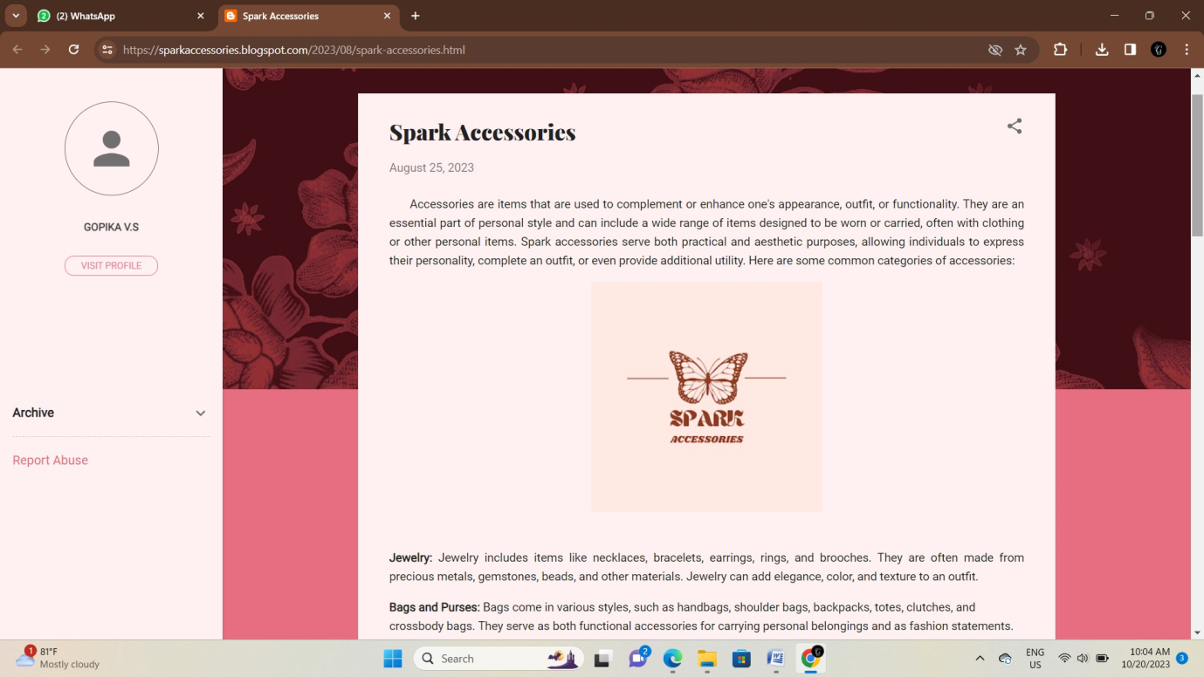

**WordPress:**

[**https://sparkaccessories6.wordpress.com/2023/10/13/spark-accessories/**](https://sparkaccessories6.wordpress.com/2023/10/13/spark-accessories/)

